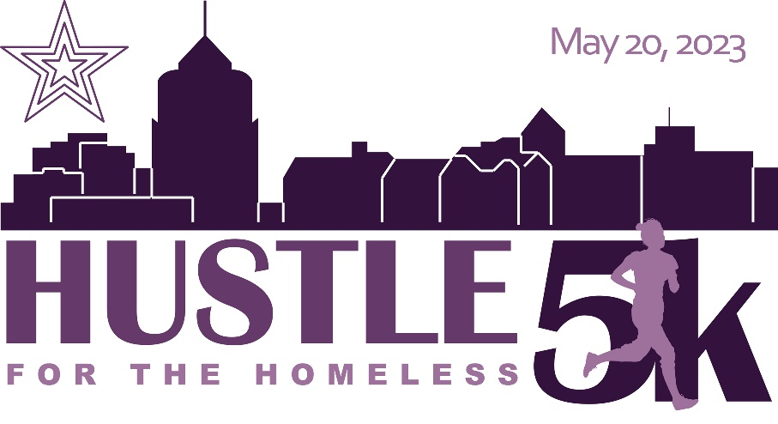

**SPONSORSHIP OPPORTUNITIES**

***Hustle for the Homeless*** is a 5K run/walk presented by *The Least of These Ministry (TLOT)* —a non-profit organization working to meet the needs of the homeless in the Roanoke Valley. The competitive version of the ***Hustle*** will take place in downtown Roanoke on Saturday, May 20, 2023 with a virtual option from May 1 - 20. This allows ample time to highlight and celebrate our sponsors to the hundreds of participants. Proceeds from this event will help us meet the physical and spiritual needs of Roanoke’s homeless. In addition to providing the basic necessities to these individuals at a street level, this ministry is also working to assist these individuals in obtaining their independence and securing permanent housing. For more information about TLOT, visit <https://www.theleastoftheseministry.org/>.

In exchange for your sponsorship, we will provide advertisement and promotional opportunities as outlined in the following categories. Thank you for supporting our mission to serve *the least of these!*

|  |  |
| --- | --- |
| **REVOLUTIONARY—$1000+**   * Info table at event, to be manned by your representative * Your signage displayed at event * Prominent logo on race shirts *(print deadline April 30th)* * Logo on *RunSignUp* page with link to your site * Shout out on Facebook event page with link to your site * Shout out and logo on race packet handout * Free race registration (up to 10 people) | **CHAMPION—$500**   * Your signage displayed at event * Logo on race shirts *(print deadline April 30th)* * Logo on *RunSignUp* page with link to your site * Shout out on Facebook event page with link to your site * Shout out and logo on race packet handout * Free race registration (up to 5 people) |
| **HERO—$250**   * Logo on race shirts *(print deadline April 30th)\** * Logo on *RunSignUp* page * Shout out on Facebook event page and race packet handout * Free race registration (2 people) | **WARRIOR—$100**   * Shout out to you [Individual or Family name] on our Facebook event page and race packet handout * Free race registration (1 person) |

--------------------------------------------------------------------------------------------------------------------------------------------------------------------------------

YES! I want to be a sponsor of the Hustle for the Homeless 5K! (Please check the desired sponsorship level.)

|  |  |
| --- | --- |
| *Corporate/Business Sponsorships:*  ❑ **Revolutionary Level $1000+ (specify amount): $1,000**  ❑ **Champion Level $500**  ❑ **Hero Level $250**  *Individual/Family Sponsorship:*  ❑ **Warrior Level $100** | Sponsor Name _______________________________________  Phone Number _______________________________________  Email _______________________________________________  Signature ____________________________________________  Date ________________________________________________ |

**PLEASE MAKE CHECKS PAYABLE TO: The Least of These Ministry**

**MAIL CHECKS AND SPONSORSHIP FORM TO: 602 Marshall Ave SW, Roanoke VA 24016**

**\*EMAIL YOUR BUSINESS NAME/LOGO to Dawn Sandoval at roaleastofthese@yahoo.com on or before May 1st**

**Questions? Email roaleastofthese@yahoo.com or call (540) 556-3200**

**­www.runsignup.com/race/va/roanoke/hustleforthehomeless**