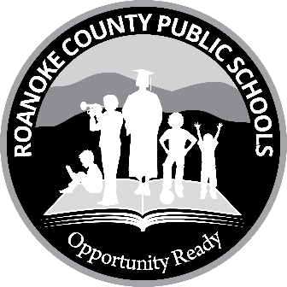
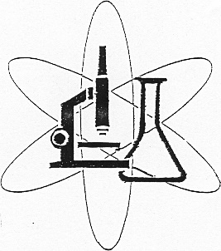
Roanoke County Public Schools

Science Instruction

5937 Cove Road
Roanoke, VA 24019
540-562-3900, ext. 10254

September 14, 2022

To Whom It May Concern:

Roanoke County Schools is committed to supporting science ingenuity. Every year we host a district science fair competition where students can display their hard work and results. The partnership activities between businesses and public schools are vital to the continued development of better education. We are requesting your support in sponsoring the Roanoke County Science Fair. Your help with a gift certificate, prize, or tax-exempt donation would be greatly appreciated. There are special branding benefits depending on your level of sponsorship:

Presenter Sponsor is open to a single sponsor who donates $3000. The presenting sponsor will receive platinum level recognition in addition to a presentation table at the Roanoke County Science Fair.

Platinum Level Sponsors who donate a minimum of $1000 will receive prominent banner placement at the science fair event, receive signature recognition in the opening and closing titles of the video, be recognized both during and after the science fair, and be included in the event program.

Gold Level Sponsors who donate a minimum of $500 will receive banner recognition, be mentioned in the closing titles of the video, and will be included in the event program.

Silver Level Sponsors who donate a minimum of $250 will receive recognition in the event program.

Patron Sponsors who donate with gift certificates and prizes will also be noted in the event program.

The Science Fair will be held on Saturday, Feb. 11, 2023, at Northside High School located at 6758 Northside High School Road in Roanoke. You are invited to view these exhibits at our open house which will begin at noon.

If you would like to support tomorrow’s STEM leaders and innovators, please make checks payable to Roanoke County Schools – Memo: Science Fair and mail to Science Supervisor, Roanoke County Public Schools, 5937 Cove Road, Roanoke, VA 24019. Gift certificates and/or prizes also can be sent to this address.

Thank you for your support of the Science Fair and Roanoke County Public School students. We appreciate your help and welcome any questions.

Sincerely,

Tammy Brown Sauls
Science Supervisor
tbsauls@rcps.us

